## **EFFICIENT PRESCRIPTION DATA ENTRY IN EMR SOFTWARE**

## A PROJECT REPORT

*Submitted by*

# **TANMAY SHUKLA [Reg No:RA2011003010119]**

# **KHUSHI SURI [Reg No: RA2011003010129]**

*Under the Guidance of*

# **Dr. S. Pradeep**

Associate Professor, Department of Computing Technologies

*in partial fulfillment of the requirements for the degree of*

**BACHELOR OF TECHNOLOGY**

# **in**

**COMPUTER SCIENCE AND ENGINEERING**



**DEPARTMENT OF COMPUTING TECHNOLOGIES**

**COLLEGE OF ENGINEERING AND**

**TECHNOLOGY**

**SRM INSTITUTE OF SCIENCE AND**

**TECHNOLOGY KATTANKULATHUR– 603 203**

**NOVEMBER 2023**



SRM INSTITUTE OF SCIENCE AND TECHNOLOGY

KATTANKULATHUR–603 203

BONAFIDE CERTIFICATE

Certified that 18CSP107L project report titled “**EFFICIENT PRESCRIPTION DATA ENTRY IN EMR SOFTWARE**” is the bonafide work of **TANMAY SHUKLA [RegNo:RA2011003010119] and KHUSHI SURI [RegNo:RA2011003010129]** who carried out the project work under my supervision. Certified further, that to the best of my knowledge the work reported here in does not form part of any other thesis or dissertation on the basis of which a degree or award was conferred on an earlier occasion for this or any other candidate.

**Dr. S. PRADEEP   Dr. M PUSHPALATHA**

**SUPERVISOR HEAD OF THE DEPARTMENT**

**PANEL HEAD**

Associate Professor

Department of Computing         Department of Computing Technologies Technologies

**SRM Institute of Science and Technology Own Work Declaration Form**

**Degree/ Course** **: B.Tech in Computer Science and Engineering**

**Student Name :** TANMAY SHUKLA, KHUSHI SURI

**Registration Number :** RA2011003010119, RA2011003010129

**Title of Work :** EFFICIENT PRESCRIPTION DATA ENTRY BY

EMR SOFTWARE

I/We here by certify that this assessment compiles with the University’s Rules and Regulations relating to Academic misconduct and plagiarism, as listed in the University Website, Regulations, and the Education Committee guidelines.

I / We confirm that all the work contained in this assessment is our own except where indicated, and that we have met the following conditions:

* + Clearly references / listed all sources as appropriate
  + Referenced and put in inverted commas all quoted text (from books, web, etc.)
  + Given the sources of all pictures, data etc. that are not my own.
  + Not made any use of the report(s) or essay(s) of any other student(s)either past or present
  + Acknowledged in appropriate places any help that I have received from others (e.g. fellow students, technicians, statisticians, external sources)
  + Compiled with any other plagiarism criteria specified in the Course hand book / University website

I understand that any false claim for this work will be penalized in accordance with the University policies and regulations.

|  |
| --- |
| **DECLARATION:** |
| I am aware of and understand the University’s policy on Academic misconduct and plagiarism and I certify that this assessment is my / our own work, except where indicated by referring, and that I have followed the good academic practices noted above.  **Student 1 Signature:**  **Student 2 Signature:**  **Date:** |
| If you are working in a group, please write your registration numbers and sign with the date for every student in your group. |

**ACKNOWLEDGMENT**

We express our humble gratitude to **Dr. C. Muthamizhchelvan**, Vice Chancellor, SRM Institute of Science and Technology, for the facilities extended for the project work and his continued support.

We would like to express our warmth of gratitude to our Registrar **Dr. S. Ponnusamy**, for his encouragement.

We wish to thank **Dr. T.V. Gopal**, Professor & Dean, College of Engineering and Technology, SRM Institute of Science and Technology, for his valuable support and encouragement.

We would like to express our heartfelt thanks to Chairperson, School of Computing **Dr. Revathi Venkataraman**, for imparting confidence to complete my course project.

We extend my gratitude to **Dr. M Pushpalatha,** Professor and Head, Department of Computing Technologies.

We wish to express our sincere thanks to Panel Head **Dr. S. Pradeep**,Associate Professor, Department of Computing Technologies, and Panel Members **Dr. G. Ramya, Dr. S. Ramesh, Dr. K. Priyadharshini,** **Dr. L. K. Shobha** Assistant Professor, Department of Computing Technologies, for their constant encouragement and support.

We are highly thankful to our Project Guide, **Dr. S. Pradeep** Associate Professor, Department of Computing Technologies for his assistance, timely suggestion, and for providing us an opportunity to pursue our project under his mentorship. He provided us the freedom and support to explore the research topics of our interest. His passion for solving real problems and making a difference in the world has always been inspiring.

Finally, we thank our parents and friends near and dear ones who directly and indirectly contributed to the successful completion of our project. Above all, we thank the almighty for showering his blessings on us to complete our Course project.

**ABSTRACT**

The efficient and accurate recording of electronic prescription data is critical in the ever-changing world of healthcare. As we push farther into this subject, a novel answer emerges, one that bridges the speed gap between handwritten methods and the digital environment. This novel technique is based on a thorough knowledge of the cognitive processes that underpin manual prescription creation, and it results in a dramatic redesign of the digital interface. The integration of predictive algorithms and tailored templates into the electronic prescription system is at the heart of our approach. We want to achieve speeds comparable to the traditional, handwritten approach by streamlining the frequently tedious and time-consuming data entering process. This major improvement not only streamlines workflow but also adds to better patient care, more effective pharmacy operations, and important data for research. Our methodology will be iterative, with extensive analysis, intelligent design, and rigorous testing. Throughout this trip, we will create and test a prototype that promises to outperform traditional, manual prescription entry methods. We hope to bridge the gap between tradition and innovation by providing a seamless and effective solution that combines the comfort of handwritten prescriptions with the numerous benefits of digital Electronic Medical Records (EMR). In our pursuit of perfection, our research aims to make the shift from pen and paper to digital interfaces as easy and efficient as possible, while maintaining the critical requirements of usability and precision. This novel approach aims to transform how healthcare professionals interact with prescription data, paving the way for a future in which electronic prescription entry is not only faster but also more accurate, resulting in better patient care, streamlined pharmacy operations, and a rich source of data for the advancement of healthcare research.

iii

**TABLE OF CONTENTS**

**ABSTRACT iii**

**TABLE OF CONTENTS iv**

**LIST OF TABLES vi**

**LIST OF FIGURES vii**

**ABBREVIATIONS viii**

|  |  |  |
| --- | --- | --- |
| 1 | INTRODUCTION | 1 |
|  | 1.1 About Project Problem | **1** |
|  | 1.2 Scope | **2** |
|  | 1.3 Purpose | **2** |
|  | 1.4 Motivation | **3** |
|  | 1.5 Problem Statement | **3** |
| 2 | **LITERATURE SURVEY** | **4** |
|  | 2.1 Related Work | **4** |
|  | 2.2 Research Gaps | **8** |
|  | 2.3 Objective of the Study | **9** |
| 3 | **SYSTEM A****RCHITECTURE AND DESIGN** | **10** |
|  | 3.1 System Analysis | **10** |
|  | 3.1.1 Functional Requirements | **11** |
|  | 3.1.2 Non-functional Requirements | **12** |
|  | 3.2 System Requirement Specification | **13** |
|  | 3.2.1 Software Specification | **13** |
|  | 3.2.2 Hardware Specification | **14** |

iv

|  |  |  |
| --- | --- | --- |
|  | 3.3 Design of Modules | 15 |
|  | 3.2.2 Initialize Design Definition | **17** |
|  | 3.4 System Diagrams | **19** |
|  | 3.4.1 Data Flow Diagram | **20** |
|  | 3.4.2 UML Diagram | **21** |
|  | 3.4.3 ER Diagram | **22** |
|  | 3.4.4 Architecture Diagram | **23** |
| 4 | **METHODOLOGY** | **24** |
|  | 4.1 About System Implementation | **24** |
|  | 4.2 Module Description | **24** |
| 5 | **CODING AND TESTING** | **27** |
|  | 5.1 Coding Snapshots | **27** |
|  | 5.2 Source Code | **31** |
|  | 5.3 Testing | **40** |
|  | 5.3.1 About Testing | **40** |
|  | 5.3.2 Test Cases | **41** |
| 6 | **RESULT AND DISCUSSION** | **46** |
| 7 | **CONCLUSION AND FUTURE ENHANCEMENTS** | **49** |

**REFERENCES ix**

**APPENDIX x**

**A CONFERENCE PUBLICATION 52**

**B JOURNAL PUBLICATION 53**

**C PLAGIARISM REPORT 55**

v

**LIST OF TABLES**

|  |  |  |
| --- | --- | --- |
| 5.1 | Unit Testing | 42 |
| 5.2 | Integration Testing | 43 |
| 5.3 | Acceptance Testing | 45 |

vi

**LIST OF FIGURES**

|  |  |  |
| --- | --- | --- |
| 1.1 | Data Flow Diagram | 3 |
| 1.2 | UML Diagram | 7 |
| 1.3 | ER Diagram | 8 |
| 1.7 | Architechture Diagram | 9 |
| 1.8 | AlexNet Architecture | 10 |
| 3.1 | Architecture Diagram of Website | 15 |
| 3.2 | Home page | 16 |
| 4.1 | Architecture flow of paper | 22 |

vii

**LIST OF SYMBOLS AND ABBREVIATIONS**

**MERN** MongoDB, Express.js, React and Node.js

**EMR** Electronic Medical Records

**QTY** Quantity

**PT** Patient

**MED** Medication

**Rx** Prescription

**MD** Medication Doctor

**HPI** History of Present Illness

**DX** Diagnosis

viii

**CHAPTER 1**

**INTRODUCTION**

* 1. **ABOUT PROJECT PROBLEM**

Efficient prescription data entry stands as a vital component of modern healthcare, with a persistent gap between current EMR software and traditional handwritten methods regarding speed. A novel solution emerges to synchronize electronic prescription input with the swiftness inherent in manual approaches. Through an examination of the cognitive flow in manual prescription creation, the software interface undergoes a redesign, mirroring this analog process within a digital framework. The incorporation of predictive algorithms and customized templates serves to predict and streamline data input, resulting in expedited information retrieval. This transformation not only amplifies workflow efficiency but also elevates patient care, pharmacy operations, and research initiatives. Throughout iterative phases of analysis, design, and testing, a prototype materializes and is subjected to evaluation in comparison to conventional methods. The overarching goal of this endeavor is to bridge the convenience of handwritten prescriptions with the advantages of digital EMR, thereby ensuring swift and precise prescription data entry while preserving user-friendliness and efficacy.

1

* 1. **SCOPE**

In the healthcare software domain, a minor yet critical aspect under scrutiny is prescription data entry. Aiming for comprehensive enhancements, the project adopts the MERN stack to revamp the software interface. The primary objective is to simplify and streamline the input of prescription data. To further bolster efficiency, the team is developing predictive algorithms and templates. The project follows an iterative methodology, incorporating phases of analysis, design, and rigorous testing for optimal performance and user satisfaction. A prototype will undergo evaluation, comparing it to traditional handwritten prescription methods. The overarching goal is to expedite prescription entry, maintaining precision and user-friendliness. The potential benefits extend to patient care, pharmacy operations, and healthcare research, envisioning a brighter and more efficient future in the healthcare domain.

* 1. **PURPOSE**

In the realm of healthcare, a minor yet significant initiative is in progress, focusing on the seamless entry of prescription data through an Electronic Medical Records (EMR) software developed with the MERN stack (MongoDB, Express, React, Node.js). This undertaking addresses a critical industry need - the swift and precise recording of prescriptions, traditionally relying on handwritten methods prone to errors. The goal is to leverage structured data and predictive algorithms to transform prescription entry, enhancing operational efficiency within healthcare systems. The endeavor envisions bridging the gap between handwritten prescriptions and the benefits of electronic medical records, promising time savings for healthcare professionals and more accurate prescription entry. The ultimate mission is to improve patient care, streamline pharmacy operations, and provide valuable healthcare research data, resulting in superior healthcare outcomes.

2

* 1. **MOTIVATION**

In today's healthcare environment, the importance of efficient prescription data input cannot be overstated. It plays a pivotal role in delivering top-notch patient care, streamlining pharmacy operations, and advancing medical research. Regrettably, existing EMR software often lags behind handwritten methods in terms of speed, leading to operational inefficiencies that impact healthcare providers and patients alike. This endeavor has its roots in the pressing necessity to bridge the gap between conventional and electronic prescription processes. The primary objective is to enhance healthcare services by meticulously analyzing the cognitive workflow of manual prescription preparation and introducing innovative software solutions. This project holds the potential to revolutionize prescription data entry, offering rapid and precise input, all the while ensuring user-friendly interfaces and optimal efficiency.

* 1. **PROBLEM STATEMENT**

In the realm of healthcare, efficient and accurate prescription data entry stands as a paramount task. A dedicated minor project undertakes this mission, harnessing the robust MERN (MongoDB, Express, React, Node.js) stack for an Electronic Medical Records (EMR) software solution that optimizes the process. The traditional handwritten prescription approach is notorious for its time-intensive data input and error potential, with implications for patient well-being, pharmacy operations, and medical investigations. Through innovative user interfaces and predictive algorithms, the project aims to significantly alleviate data entry burdens while maintaining user-friendliness and efficacy. The ultimate goal is to forge a seamless connection between the convenience of handwritten prescriptions and the advantages of electronic medical records, promising time savings for healthcare professionals and enhanced patient care, all while upholding impeccable data accuracy and integrity.

3

**CHAPTER 2**

**LITERATURE SURVEY**

**2.1 RELATED WORK**

The existing body of literature underscores the persistent challenges associated with electronic prescription data entry within the healthcare industry. Despite the advantages offered by electronic medical record (EMR) systems, handwritten prescriptions remain the preferred and most expedient choice. Concerns have arisen regarding workflow efficiency, the potential for errors, and the overall standard of patient care resulting from this enduring disparity.

Numerous studies within the healthcare domain have stressed the need to enhance EMR interfaces, aligning them more closely with the cognitive process’s integral to manual prescription preparation. These studies have recognized the potential of predictive algorithms and personalized templates to streamline data entry, thereby improving the usability of the software.

Research in this area has consistently emphasized the importance of creating user-friendly software interfaces that seamlessly integrate into healthcare practitioners' workflows. These interfaces should mirror the efficiency of handwritten methods, requiring less time and effort for prescription entry.

The findings from these studies have yielded valuable insights, fueling the collective effort to achieve a primary objective: the fusion of digital EMR systems' advantages with the practicality of handwritten prescriptions. This endeavor aims to enhance operational efficiency and patient care within the healthcare ecosystem, ultimately leading to improved healthcare delivery.

4

Certainly, here is the information from the provided sources presented in paragraph form:

1. In the 2018 study by George Linn, Yung-Hsiang Ying, and Koyin Chang, it was discovered that Dynamic Structured Data Entry (DSDE) may be more efficient and time-saving for doctors while capturing outpatient medical records than Free Text Entry (FTE). The study showed the potential benefit of DSDE in healthcare settings by using female actors as patients with gynecological problems. The research's tiny sample size, however, raises questions regarding its generalizability. The drawbacks include an emphasis on younger physicians, which may underestimate the costs of transition for older professionals, and the use of templates that only include common diseases and leave out rare or difficult ailments. Additionally, the study's small sample size raised the possibility of bias, and the observer effect might have affected the study's findings and efficiency gains.

2. The impact of electronic medical record (EMR) installation in lowering documentation mistakes and patient wait times in outpatient clinics was investigated in a systematic study by Salem Albagmi in 2021. According to the review, the use of an EMR decreased medical errors since there were fewer documentation mistakes, and it also reduced patient wait times because the entire workflow of the system was improved. Strict exclusion and inclusion criteria, which might have eliminated pertinent studies, and a dearth of information on venues, study kinds, and demographics in some studies were the review's weaknesses. Compared to patient wait times, documentation mistakes were the subject of more investigations.

3. The detrimental consequences of Electronic Medical Records (EMRs) on clinical training and patient comprehension were highlighted in Santosh G. Honavar's 2020 study. Due to the emphasis on EMRs, residents have observed a loss in education, compassion, and bedside clinical reasoning. Poor EMR design has come under fire for failing to increase efficiency, patient care, and doctor and patient satisfaction. The study stressed that instead of imposing fixes, EMRs should address actual medical practice difficulties. It also referred to India's role as a leader in the development of ophthalmology EMR, which included users like Sankara Nethralaya and TCS.

5

4. The impact of data input structure on patients' perceptions of information quality in the context of Health Information Exchange (HIE) was thoroughly investigated in a research study carried out in 2020 by Pouyan Esmaeilzadeh, Tala Mirzaei, and Mahed Maddah. The study's conclusions showed that the degree of structure in the data input had a significant impact on a number of patient evaluations of health information, including completeness, accuracy, psychological safety, data accessibility, succinctness, and comprehensibility.

5. In research conducted in the year 2020 by Ekhlas Abu Sharikh, Rifat Shannak, Taghrid Suifan, and Omar Ayaad, an investigation was undertaken to explore the influence of electronic medical record features on the quality of healthcare services. The study revealed that the utilization of electronic medical records had a statistically significant impact on healthcare services. The impact was categorized based on functions such as practice management, communication, documentation or data entry, and medication management, as well as service quality factors including reliability, responsiveness, assurance, and empathy.

6. Harm Maarsingh, Kayla Oyler, Gamukama Tuhaise, Mariette Sourial, Adwoa O. Nornoo, Wambazu Moses, and Laura A. Rhodes conducted a study in 2022 that demonstrated the successful implementation of electronic health records during a medical service trip. The communication between various medical stations was substantially enhanced by this implementation, which resulted in more smooth patient care transitions. It's important to note that the number of patients seen by each doctor in an hour increased by 45% and the number of prescriptions filled in an hour increased by 38% as a result of the transition from paper records to electronic health records.

7. A 2022 study by Amr Farghali, Elizabeth M. Borycki, and Scott Macdonald investigated the opinions of community pharmacists in Canada regarding the advantages of e-prescribing. According to the report, Canadian pharmacists are eager to adopt technology, particularly e-prescribing systems, into their operations in order to boost productivity and cut down on mistakes. However, the majority of prescriptions are still written by hand, showing a low level of e-prescribing

6

8. In their cross-country analysis from 2021, Bader Aldughayfiq and Srinivas Sampalli compared the e-Prescription networks across eight countries. The study evaluated national prescription systems that included elements like two-way pharmacy-prescriber communication and electronic creation and transmission of prescriptions. The study emphasized the many ways that e-Prescription systems have been implemented because of differences in infrastructure, norms, and regulations between nations. Internet of Things (IoT) solutions were being incorporated into both centralized and decentralized systems to improve healthcare efficiency

9. In 2022, Alex C. Cheng, Mary K. Banasiewicz, Jakea D. Johnson, Lina Sulieman, Nan Kennedy, Francesco Delacqua, Adam A. Lewis, Meghan M. Joly, Amanda J. Bistran-Hall, Sean Collins, Wesley H. Self, Matthew S. Shotwell, Christopher J. Lindsell, and Paul A. Harris conducted an analysis of automated electronic case report form data entry from electronic health records. The majority of coordinator-completed items were found to be filled in by the automated EHR feed, and data submitted automatically and manually agreed well, according to the study.

10. An update on the advantages and disadvantages of Electronic Medical Records (EMR) in hospital treatment was given in a review by Aykut Uslu and Jürgen Stausberg in 2021. The study emphasized an increase in studies and a move from cost-focused to clinical studies, highlighting the benefits of EMR on healthcare quality. Due to different abstract and main text summaries, the review encountered issues with interrater reliability for paper selection and deriving conclusions. But the case for EMRs' beneficial benefits on healthcare is still well-established.

7

**2.2 RESEARCH GAPS**

Electronic prescription data entry in healthcare have been highlighted by the current literature review:

**1. Quickness and efficacy Disparity:** One of the biggest research gaps is the continuous speed and efficiency difference between digital electronic medical record (EMR) systems and handwritten prescription techniques. While EMRs have several advantages, such as improved data storage and retrieval, the slow speed of data entry presents a serious obstacle.

**2. Usability and user-centered design:** Numerous studies have emphasized the significance of usability and user-centric design in EMR interfaces. There is a need for more research on the best ways to include user feedback and cognitive workflow analysis into the design phase so that the software is user-friendly and seamlessly integrates into the healthcare system.

**3. Error Prevention:** The goal of electronic prescription systems should be to prevent mistakes from occurring during the prescription entering procedure. Research still needs to be done before features or procedures that reduce data entry errors in software may be used, thereby enhancing patient safety.

**4. Customized Templates and Predictive** **Algorithms:** Although the creation of customized templates and predictive algorithms has been discussed in numerous publications, nothing is known about the precise needs, flexibility, and efficacy of these tools in the context of prescription entry.

**5. Compatibility:** The literature demonstrates the necessity for thorough investigation of mechanisms for smooth data sharing that can connect dissimilar systems, improving data precision and patient care quality.

**6. Long-Term Impact and Sustainability:** Only a small amount of study has examined the sustainability and long-term effects of prescription data input methods.

**7. Patient-Centered Care:** The research analysis emphasized how crucial electronic prescription management systems are to improving patient care. There are gaps in the literature when it comes to quantifying and evaluating the direct effects on patients, such as medication adherence, safety, and overall health outcomes.

8

**2.3 OBJECTIVE OF THE STUDY**

The primary objectives revolve around enhancing the healthcare sector's efficiency and addressing issues related to electronic prescription data entry. These goals can be summarized as follows:

1. Enhancing EMR Interfaces: A crucial objective is the redesign of electronic medical record (EMR) interfaces. The aim is to make these interfaces more user-friendly and intuitive for healthcare practitioners. This redesign aligns with the cognitive processes involved in manual prescription creation.

2. Reducing Data Entry Time: To expedite the prescription data input process, the study focuses on the use of structured data, predictive algorithms, and personalized templates. This approach significantly reduces the time required compared to traditional handwritten methods.

3. Minimizing Errors: Software features are developed to mitigate data entry errors, thereby enhancing patient safety and the overall quality of care.

4. Improving Usability: The study prioritizes user-centered software development, ensuring that it seamlessly integrates into the daily workflows of healthcare professionals, ultimately enhancing overall usability.

5. Promoting Interoperability: Investigative efforts are directed towards achieving interoperability between various EMR systems, pharmacy databases, and other healthcare platforms. This fosters data accuracy and maintains high standards of patient care.

6. Scalability and Sustainability: The study evaluates the long-term viability of the proposed solution, ensuring its adaptability to evolving healthcare environments and scalability for broader implementation.

7. Patient-Centered Care: The study assesses the direct impact of improved prescription data input on patient-centered care, including medication adherence, safety, and overall health outcomes.

9

**CHAPTER 3**

**SYSTEM ARCHITECTURE AND DESIGN**

The Electronic Medical Record (EMR) interface must be user-friendly and centered in order to address the issue statement of improving electronic prescription data entry in healthcare. To speed up the prescription filling process, this interface should make use of structured data entry, predictive algorithms, and personalized templates. The system will place a strong emphasis on speeding up data entry, decreasing mistakes, and fostering usability. For seamless data transmission, it should also give top priority to compatibility with other EMR systems, pharmaceutical databases, and healthcare platforms. The system's positive impact on patient-centered care should be guaranteed while considering long-term sustainability and scalability in the design. For increased productivity and patient care in healthcare settings, the architecture strives to close the gap between handwritten and digital prescriptions.

**3.1 SYSTEM ANALYSIS**

The system analysis focuses on assessing the current healthcare data input procedures and locating issues with the electronic prescription systems. A thorough analysis of user processes, data input speed, and probable error sources is required. In order to build and construct a more effective electronic prescription input system, this phase strives to acquire key information.

10

**3.1.1 FUNCTIONAL REQUIREMENTS**

Functional requirements explain how the system functions, whereas non-functional requirements describe the constraints and characteristics of the system. This behavior can be explained in terms of the functions, duties, or prerequisites the system needs to fulfill. Key concepts are explained, and functional capturing is covered. in order to both influence architectural decisions and serve as a basis for the structure's validity. Certainly, the following list of bullet points provides the functional needs for improving electronic prescription data entry:

• User-Friendly Interface: Create an Electronic Medical Record (EMR) interface that is simple to use and user-focused.

• Structured Data Entry: Include prescription information in structured data entry areas.

Implement predictive algorithms to speed up prescription entry and reduce the need for manual data entry.

• Customized Templates: Offer special templates for various prescription types and ailments.

• Time Efficiency: Ensure quick prescription input by cutting down on data entry time compared to conventional approaches.

• Error Minimization: Create system features that reduce data entry errors, enhancing patient safety.

• Interoperability: Ensure easy data sharing with a variety of EMR systems, pharmacy databases, and healthcare platforms.

User adaptability and efficiency should be prioritized in order to fully incorporate the system into the regular workflows of healthcare professionals.

Enhance patient-centered treatment by tracking how medication adherence, safety, and overall health outcomes are directly impacted.

Ensure the system's long-term viability and scalability so that it can adapt to shifting healthcare environments and developing technological landscapes.

11

**3.1.2 NON-FUNCTIONAL REQUIREMENTS**

The improvement of electronic prescription data entry includes non-functional needs that cover system performance, security, and usability issues. These specifications guarantee the efficiency and dependability of the system. The non-functional needs are listed below in bullet points:

1. Performance: To meet the demand for quick prescription input, the system should provide high-speed data entry. To ensure user efficiency, response times for user interactions must be kept to a minimum.
2. Security: Data confidentiality and integrity should be protected, and strong encryption mechanisms should be used. To protect patient information, access control and user authentication procedures must be in place. It's crucial to adhere to healthcare data security regulations like HIPAA.
3. Usability: Healthcare workers should only need a minimal amount of training to operate the user interface. Users with disabilities must be accommodated with accessibility features. The system ought to work with a range of gadgets and screen sizes.
4. Scalability: The system should be able to handle growing user populations and data quantities without experiencing performance degradation.
5. Reliability: The system should operate reliably, with little downtime required for maintenance. In order to guarantee data integrity and system continuity, it must include backup and disaster recovery procedures.
6. Compliance: The healthcare industry's legal and regulatory regulations must be followed by the system. Audits and compliance checks ought to be performed on a regular basis.
7. Documentation: Users, administrators, and developers should have access to thorough system documentation. Training materials, technical manuals, and user manuals must be offered.

12

**3.2 SYSTEM REQUIREMENT SPECIFICATION**

A thorough breakdown of the functional and non-functional requirements for improving electronic prescription data entry in healthcare may be found in the system requirement specification. These specifications direct system design and development to guarantee top performance, usability, and security.

**3.2.1 SOFTWARE SPECIFICATIONS**

* Operating System: Supports Linux, macOS, and Windows 10.
* MERN (MongoDB, Express.js, React, Node.js) is the technology stack.
* React is a front-end framework for creating user interfaces.
* Tailwind CSS was used as the styling framework when creating the user interface.
* Back-End Framework: Express.js is a Node.js web application framework for server-side tasks.
* Database: MongoDB, a NoSQL database, is used to store and manage patient and prescription data.

Further Libraries:

* RxNorm API: To access drug information and assure accurate prescription data submission, use the RxNorm API.
* Axios: An HTTP client for making API queries that uses promises.
* Mongoose: A sophisticated tool for MongoDB object modeling in Node.js.
* Node Package Manager (npm): Control packages and project dependencies.

13

* Deployment: For accessibility and scalability, deploy the system on a cloud platform like AWS, Heroku, or Azure.
* Testing: Use the React Testing Library for the front end and implement unit and integration testing using tools like Jest for the back end.
* Documentation: Produce thorough system documentation, including an API reference for RxNorm integration.

**3.2.2 HARDWARE SPECIFICATIONS:**

The suggested system's basic hardware requirements include:

- CPU: Intel Core i5 processor

- Memory: 8 GB of RAM

- Storage: 64 GB hard disk space

- Input Devices: A physical keyboard and mouse or their virtual equivalents

14

**3.3 DESIGN OF MODULES**

System design is a vital process that entails planning and creating various elements within a system, including architecture, modules, components, interfaces, and data flow. The primary goal of this process is to provide detailed information about the system and its components, ensuring that the implementation aligns with the architectural entities specified in system architecture models and views.

**Key components of system design include:**

1. **Architecture:** This conceptual model defines the system's structure, behavior, and perspectives. Flowcharts are often used to visually represent the architecture, offering a clear overview.
2. **Modules:** Modules are essential building blocks, each handling specific tasks within the system. Combining these modules forms the system's functionality.
3. **Components:** Components encompass specific functions or groups of related functions within the system. These are composed of modules working together to fulfill their designated roles.
4. **Interfaces:** Interfaces serve as shared boundaries facilitating communication and data exchange among system components. They are vital for seamless interactions.
5. **Data:** Efficiently managing data flow is fundamental. It involves handling and processing data to ensure its smooth movement throughout the system.

The functionality of the system must be divided into independent, controllable components before modules for the electronic prescription data input system can be designed.

1. User Authentication and Access Control Module: To maintain data security, this module administers user registration, login, and authentication. It also regulates user access levels and permissions.

2. Module for Prescription Entry Interface: This module offers the user interface for entering prescription data. To speed up the entering process, it has organized data entry fields, templates, and predictive algorithms.

15

3. RxNorm API Integration Module: This module uses the RxNorm API to validate prescriptions and receive medication information. It guarantees the accuracy of prescription drugs

4. The module for managing and storing prescription data in MongoDB is called the Prescription Storage and Management Module. It controls the retrieval, updating, and deletion of data.

5. Reporting and analytics, produces reports and analytics on prescription data. It gives medical professionals and administrators insights about prescription trends, blunders, and patterns.

6. Security and Compliance, focuses on security measures, data encryption, and adherence to healthcare data standards. It guarantees that the system complies with all legal and regulatory standards.

7. Scalability and Performance Optimization Module: This module is in charge of enhancing the scalability and performance of the system. It covers resource management, performance monitoring, and load balancing.

8. System Documentation and Help Module: This module provides thorough system documentation for administrators and users. It might contain user manuals, FAQs, and resources for troubleshooting.

9. Unit, integration, and user acceptability testing are all included in the testing and quality assurance module, which is devoted to testing the system. It guarantees the consistency and excellence of the system.

10. Deployment and Hosting Module: This module is in charge of the system's deployment on a server or a cloud platform. It consists of system updates, domain configuration, and server management.

11. User Support and Communication Module: This module offers support to users, collects their comments, and responds to their problems through a variety of communication channels.

16

**3.3.1. INITIALIZE DESIGN DEFINITION**

At the outset of the design process for the electronic prescription data entry system, it's essential to establish a clear design definition. This serves as the foundation for the subsequent design phases. The design definition includes:

1. System Goals and Objectives:

- Define the primary goals of the system, which include enhancing prescription data entry efficiency, reducing errors, and improving patient care.

- Outline specific objectives such as integrating the RxNorm API for accurate medication information retrieval.

2. User Personas and Use Cases:

- Identify user personas, including healthcare professionals, pharmacists, and administrators.

- Define common use cases, such as creating new prescriptions, modifying existing ones, and accessing prescription history.

3. Functional Requirements:

- Enumerate the functional requirements, emphasizing features like predictive algorithms, customized templates, and interoperability with existing healthcare systems.

4. Non-Functional Requirements:

- pecify non-functional requirements, focusing on performance, security, usability, scalability, and compliance.

5. System Architecture:

- Outline the high-level system architecture, which is based on the MERN stack and incorporates RxNorm API integration.

6. Data Flow Diagram:

- Create a data flow diagram to illustrate how data will be processed and flow through the system.

7. User Interface Design Guidelines:

- Define user interface design guidelines, including the use of Tailwind CSS for responsive and user-friendly UI elements.

17

8. Integration Strategy:

- Describe the strategy for integrating the RxNorm API, ensuring that it aligns with data entry and validation processes.

9. Data Management:

- Specify how prescription data will be stored in MongoDB and the database schema.

10. Testing Approach:

- Describe the testing methodology, taking into account user acceptability testing, integration testing for system components, and unit testing for individual modules..

11. Documentation Plan:

- Develop a plan for comprehensive system documentation, including user manuals, API documentation, and technical guides.

12. Deployment Strategy:

- Outline the strategy for deploying the system, whether on a cloud platform or on-premises, considering scalability and performance.

13. User Support and Training:

- Describe the support and training approach for assisting users and addressing their needs.

14. Compliance and Security Measures:

- Specify measures to ensure compliance with healthcare regulations and standards, as well as data security protocols.

This design definition provides a clear and structured framework for the subsequent design phases, ensuring that the system's development aligns with its goals, objectives, and the needs of its users.

18

**3.4 SYSTEM DIAGRAMS**

In a small-scale prescription data entry system developed with the MERN stack, several essential components work in harmony to provide a seamless user experience.

The User Interface plays a pivotal role in this ecosystem. Its primary function involves rendering information to the user and facilitating interactions with the system. React, a versatile JavaScript library renowned for crafting engaging user interfaces, is employed to create this front-end component.

On the server side, the system relies on Node.js as the runtime environment, coupled with MongoDB, a NoSQL database. Node.js handles data processing and storage efficiently, ensuring the system's responsiveness and scalability. MongoDB, on the other hand, serves as the data repository, excelling in managing prescription data due to its proficiency in handling JSON data.

The crucial communication link between the User Interface and the Server Side is established through REST APIs. Requests initiated by the User Interface to retrieve or update prescription data are transmitted to the Server Side, which then processes these requests. Once processed, the Server Side sends back the results, which are subsequently displayed on the User Interface. This seamless interaction between these components ensures the efficient functioning of the prescription data entry system, enhancing user experience and data management.

19

**3.4.1 DATA FLOW DIAGRAM**

In order to construct Electronic Medical Record (EMR) software utilizing the MERN stack, a Data Flow Diagram (DFD) is essential. It acts as a visual depiction of the data flow inside the system, showing the input, processing, output, and storage procedures. Understanding the complex data dynamics in the healthcare industry greatly depends on DFDs. They play a crucial role in enabling effective prescription data input and helping to build a smooth and effective EMR system.

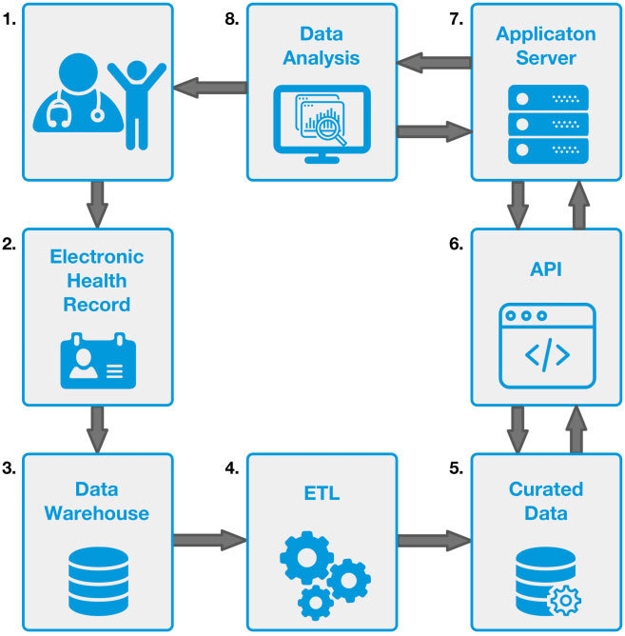

**Figure 4.1: Data-Flow Diagram for the system**

20

**3.4.2 UNIFIED MODELING LANGUAGE (UML) DIAGRAM**

Unified Modeling Language, or UML for short, is a standardized modeling language that is extensively employed in the discipline of object-oriented software engineering. This standard is managed and kept up to date by the Object Management Group. The main goal of UML is to provide a uniform language for modeling computer software using an object-oriented methodology. The two primary parts of UML are a notation system and a meta-model. There might be more techniques or UML-integrated processes added in the future.

Best engineering techniques that have been shown to work well when modeling complex, large-scale systems are stored in UML. It is essential to the creation of object-oriented software as well as the process of developing software in general.

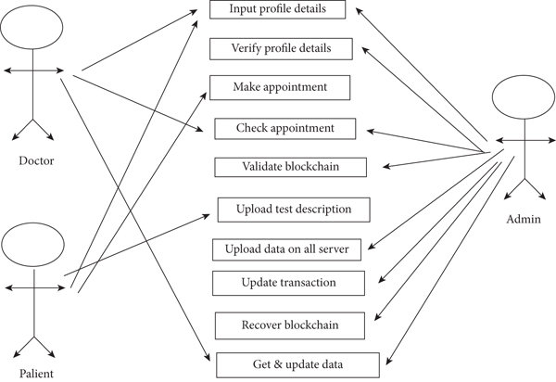

**Figure 4.3: Use Case Diagram for System**

21

**3.4.3 ENTITY RELATION (ER) DIAGRAM**

A graphical depiction of a database's structure and relationships is called an Entity Relationship Diagram (ER). This visual tool is very helpful for building, documenting, and troubleshooting databases since it uses symbols to represent different components, such as entities, attributes, and relationships. Three essential components make up the ER diagram: relationships, entities, and attributes. Entities are the things or ideas that are stored in the database; attributes are the qualities or features of these entities; and relationships show the connections or linkages between various entities.

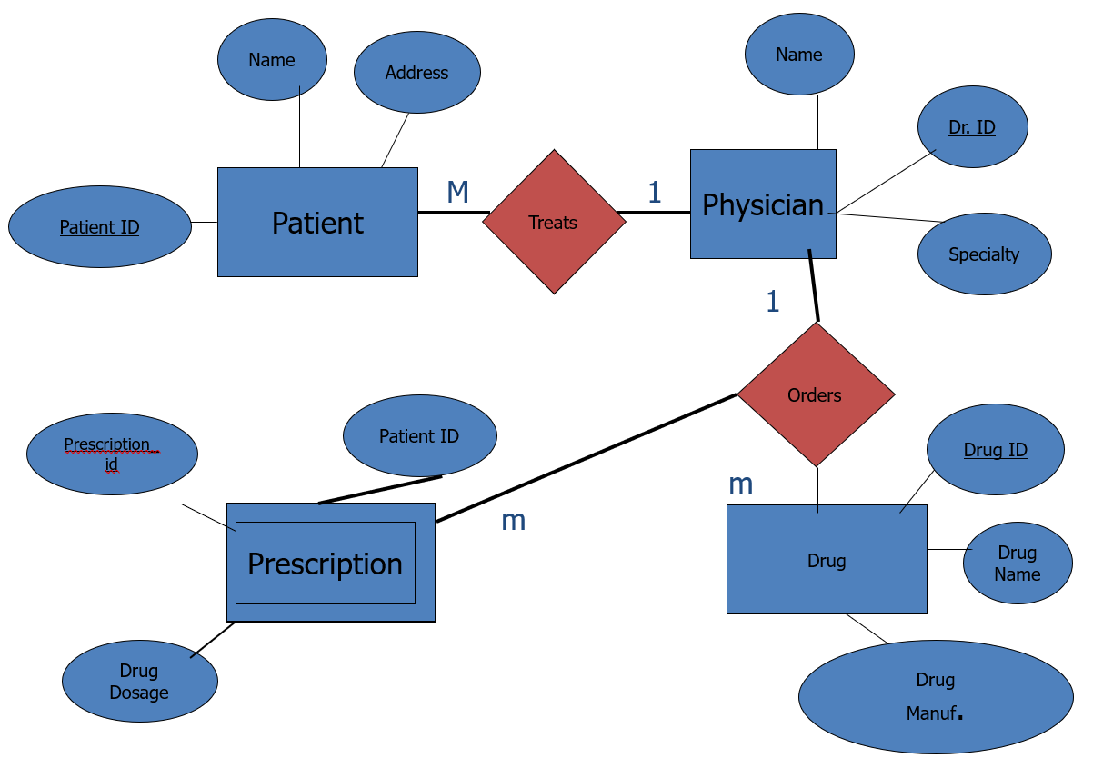

**Figure 4.4: Entity Relationship Diagram for System**

22

**3.4.4 ARCHITECTURE DIAGRAM**

An architecture diagram is a graphic depiction that shows how a software system, or any other system, is organized and connected. It makes use of a variety of lines and symbols to represent the components, characteristics, and relationships of the system. Architectural diagrams are useful resources for system design, documentation, and troubleshooting. They are available in a variety of formats, such as application, integration, and deployment architectural diagrams, each of which has a unique purpose and offers insights into various aspects of the system.

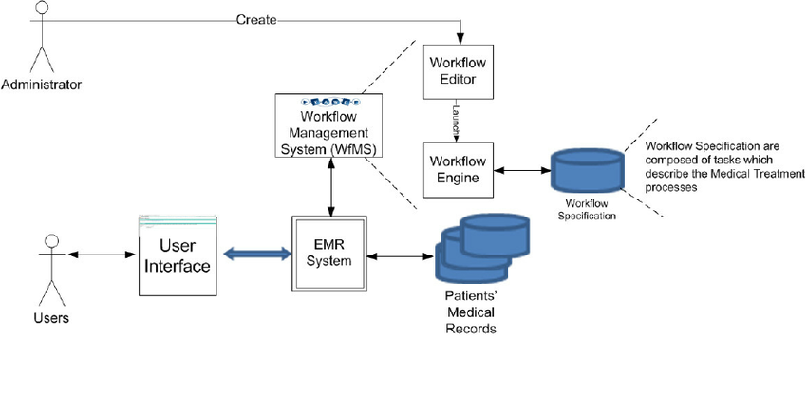

**Figure 4.5: Architecture Diagram for System**

23

**CHAPTER 4**

**METHODOLOGY**

**4.1 ABOUT SYSTEM IMPLEMENTATION**

In the implementation of our Electronic Medical Records (EMR) software using the MERN stack, our methodology revolves around creating a seamless and efficient prescription data entry system. We began by designing an intuitive user interface for healthcare professionals, ensuring ease of use and quick access to patient records. Leveraging the power of the MERN stack, we integrated robust databases for secure data storage and retrieval. The implementation also involved rigorous testing and fine-tuning to guarantee data accuracy and system reliability. Overall, our system prioritizes precision, accessibility, and the utmost security for managing prescription data within the healthcare ecosystem.

**4.2 MODULE DESCRIPTION**

The electronic prescription data entry system consists of several interlinked modules, each tailored for specific functions. These modules function cohesively to fulfill the system's overarching objectives.

**4.2.1 User Authentication and Access Control Module:**

* This module is responsible for user registration, login, and authentication.
* It enforces access control and permissions, ensuring that the right users have access to specific system features.

24

**4.2.2 Prescription Entry Interface Module:**

* The prescription entry module provides the user interface for entering prescription data.
* It offers structured data entry forms, customizable templates, and predictive algorithms to streamline the data entry process.

**4.2.3 RxNorm API Integration Module**

* This module connects with the RxNorm API to retrieve accurate drug information and validate prescriptions in real-time.
* It ensures that the prescribed medications are up-to-date and accurate, reducing errors in medication prescriptions.

**4.2.4 Prescription Storage and Management Module:**

* This module handles the storage, retrieval, and management of prescription data in the MongoDB database.
* It enables users to access, update, and delete prescription records while maintaining data integrity.

**4.2.5 User Profile and Preferences Module:**

* Users can manage their profiles and customize their interface preferences within this module.
* It may include options for language preferences, template customization, and accessibility settings.

25

**4.2.6 Scalability and Performance Optimization Module:**

* This module is responsible for optimizing system performance and scalability.
* It may include load balancing, resource management, and performance monitoring to ensure the system can handle increased workloads.

**4.2.7 Testing and Quality Assurance Module:**

* Quality assurance and testing procedures are conducted within this module.
* Errors related to module interfaces can be found and fixed simultaneously with the program structure through the methodical process of integration testing. This approach culminates in the combination of all modules and a thorough comprehensive testing of the program as a whole.

The electronic prescription data entry system relies on a well-coordinated network of modules to enhance prescription procedures, enhance patient care, minimize errors, and uphold data security and compliance. Each module has a crucial function, working together seamlessly to ensure the system's efficiency and overall effectiveness.

26

**CHAPTER 5**

**CODING AND TESTING**

**5.1 CODING SNAPSHOTS**

**5.1.1)BACKEND**

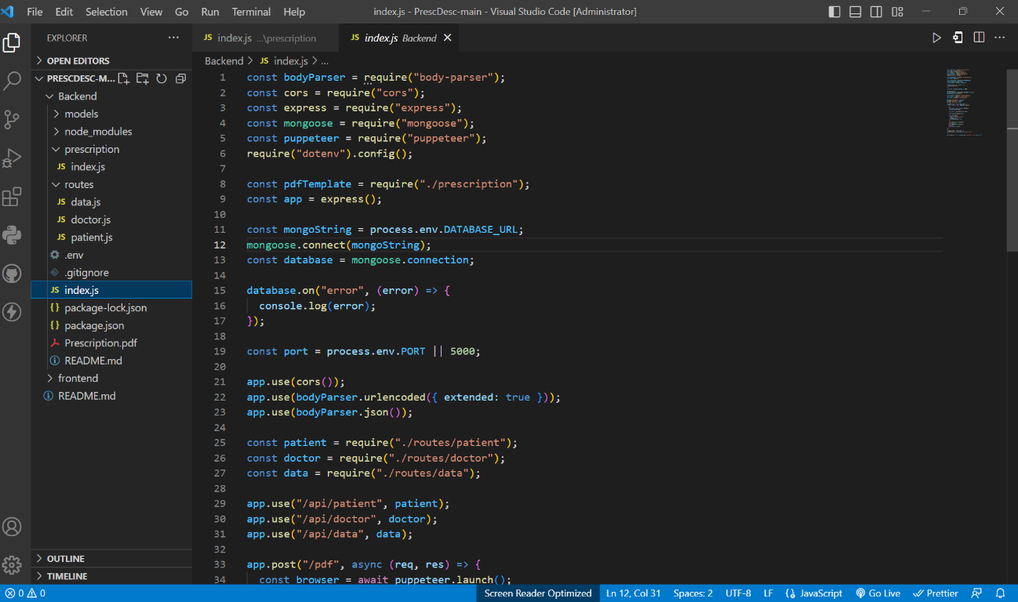

27

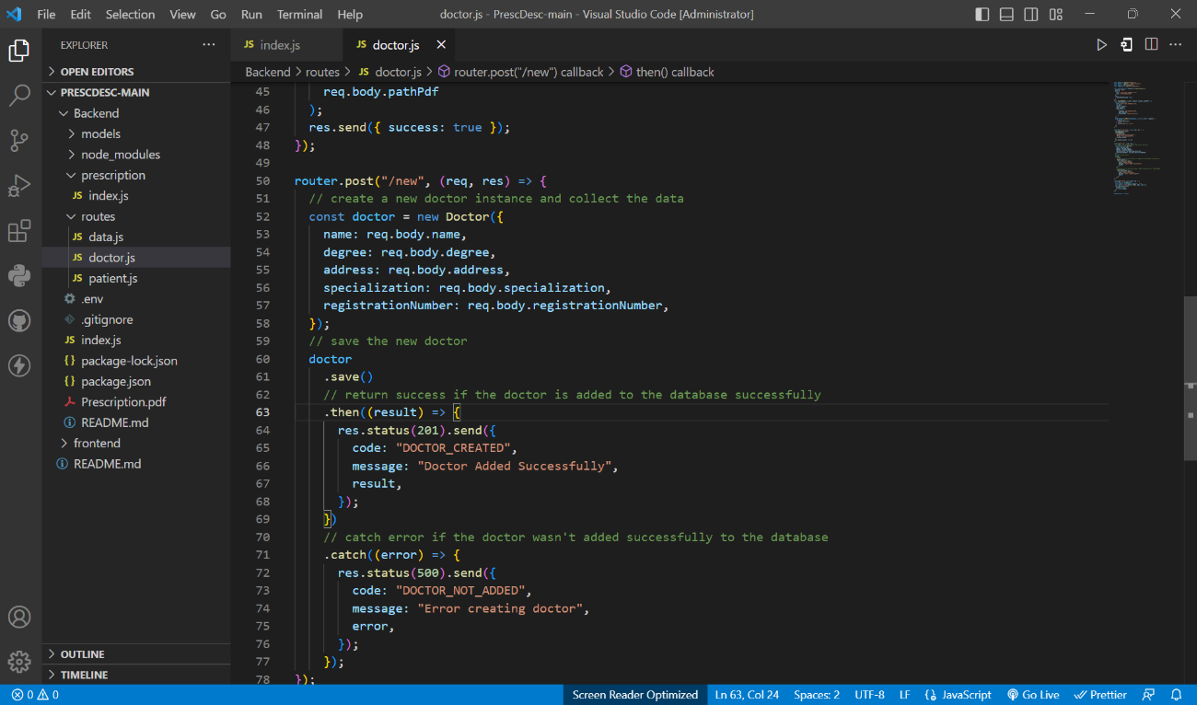

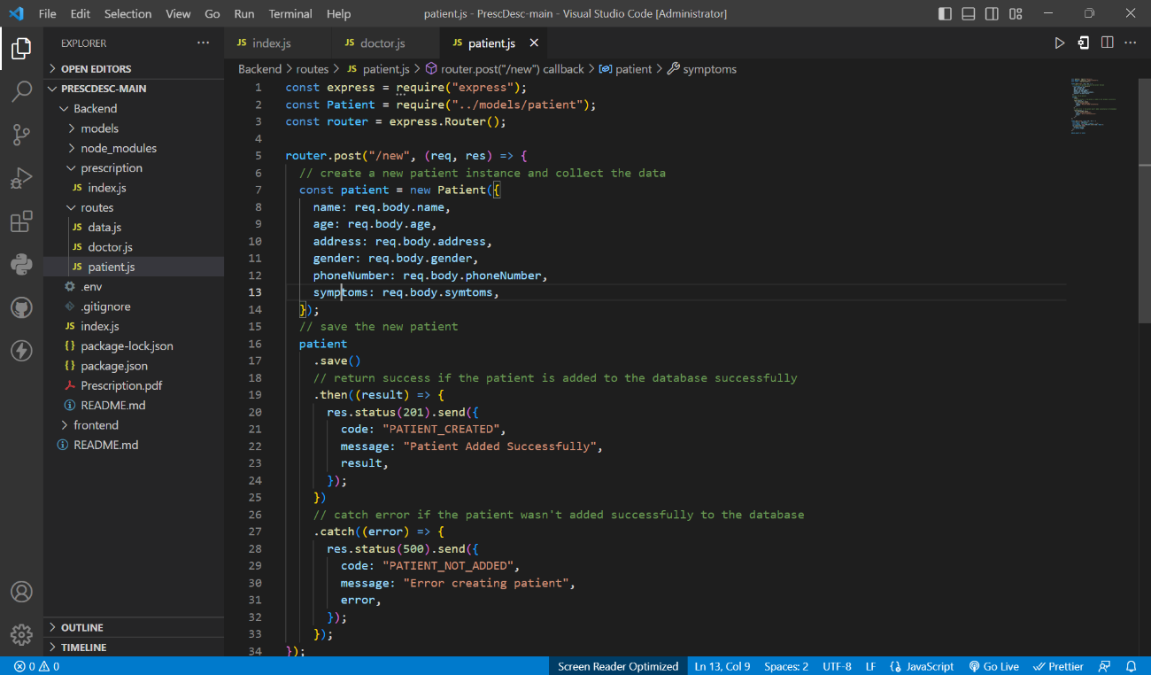

28

**5.1.2)FRONTEND**

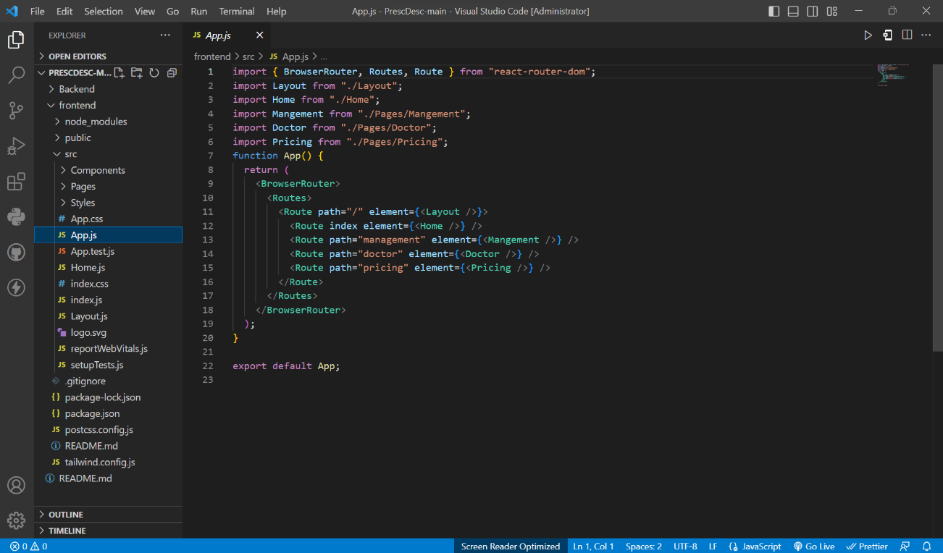

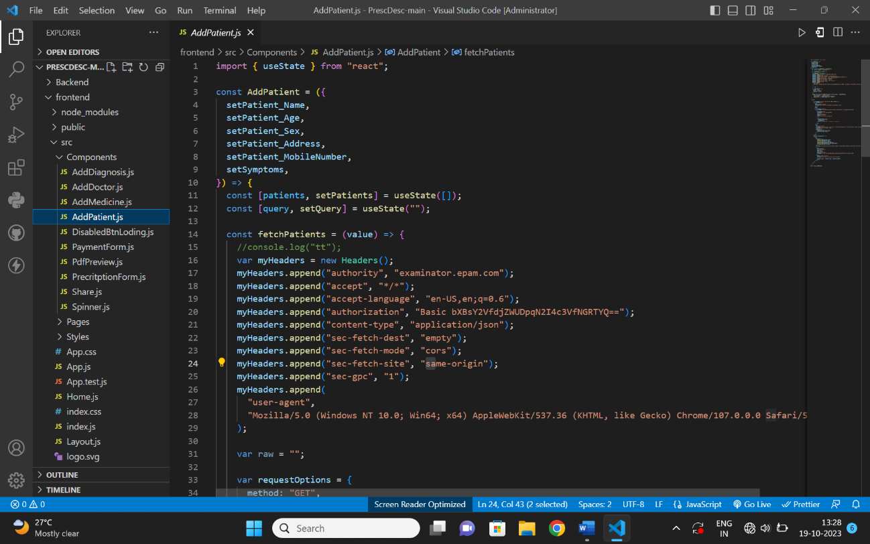

29

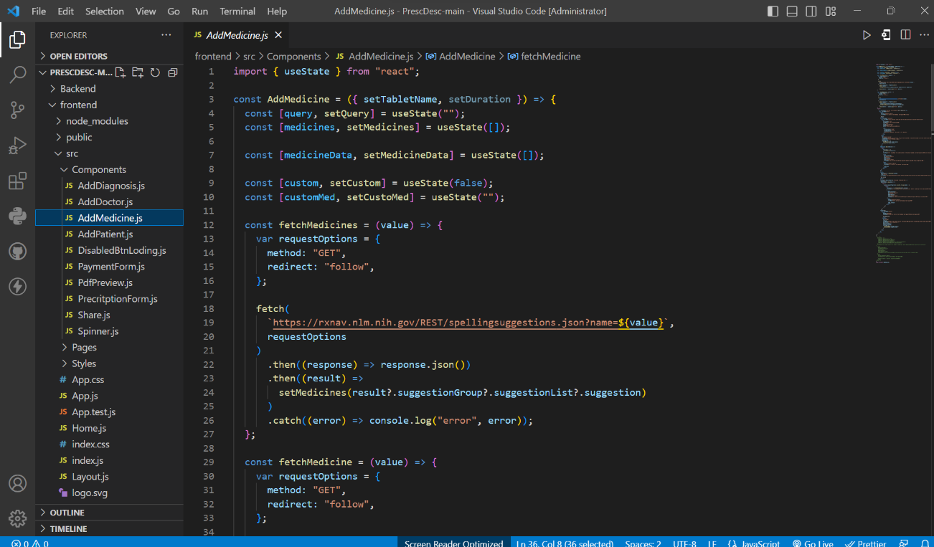

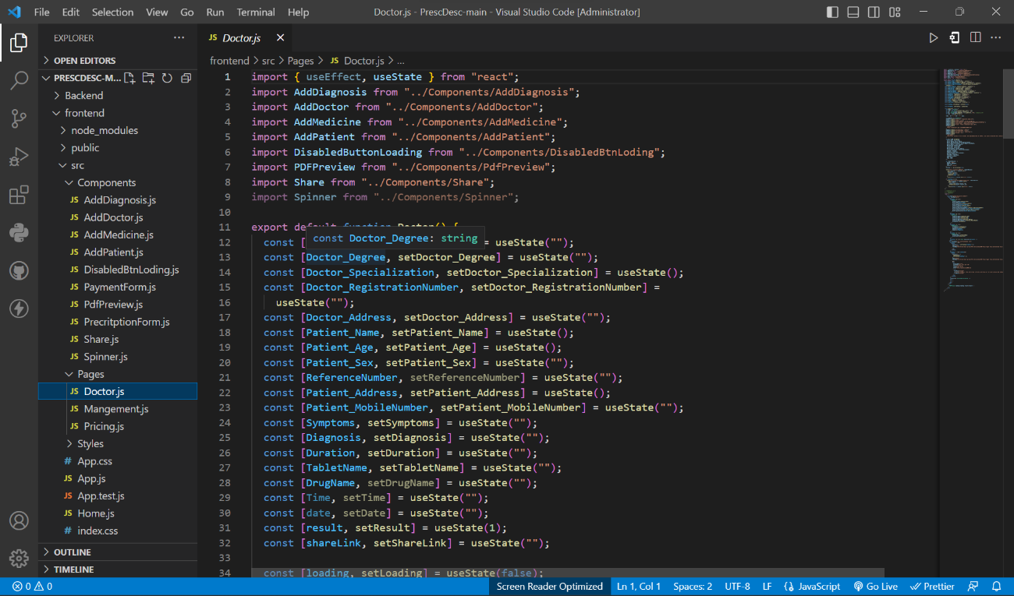

30

**5.2 SOURCE CODE**

**5.2.1 BACKEND**

**Index.js**

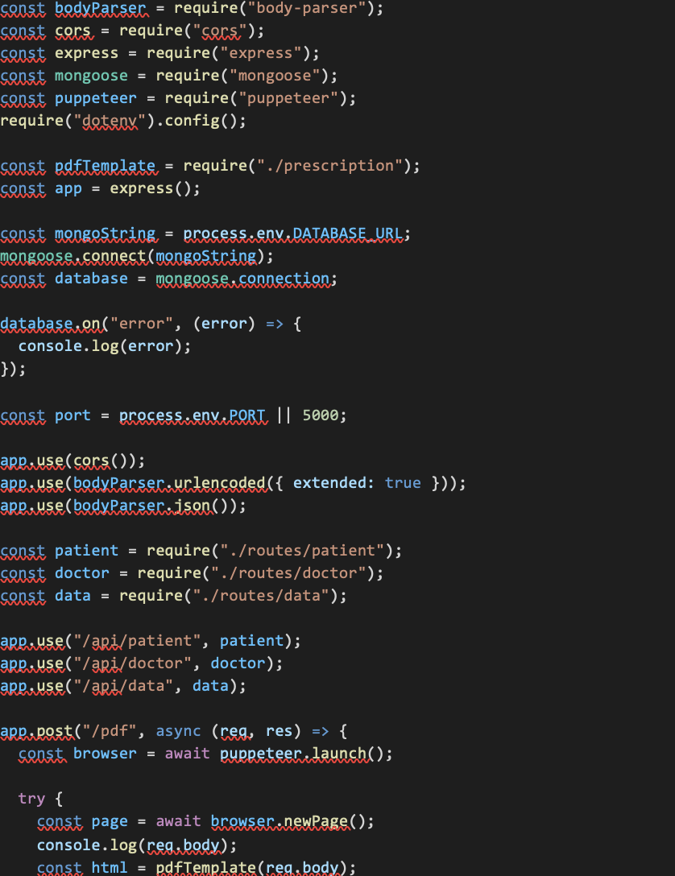

31

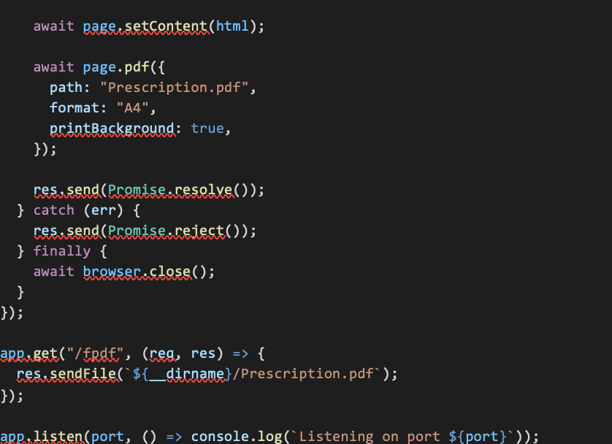

**Data.js**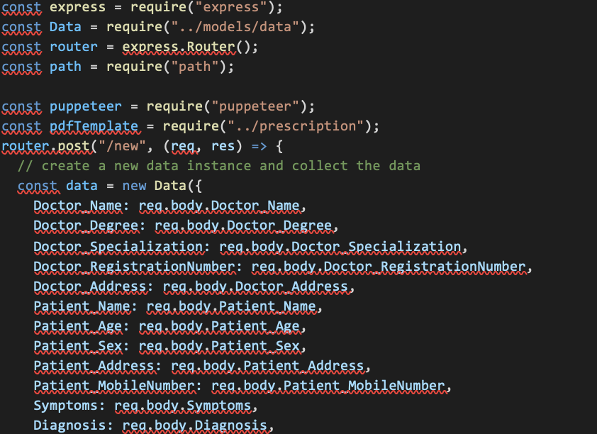

32

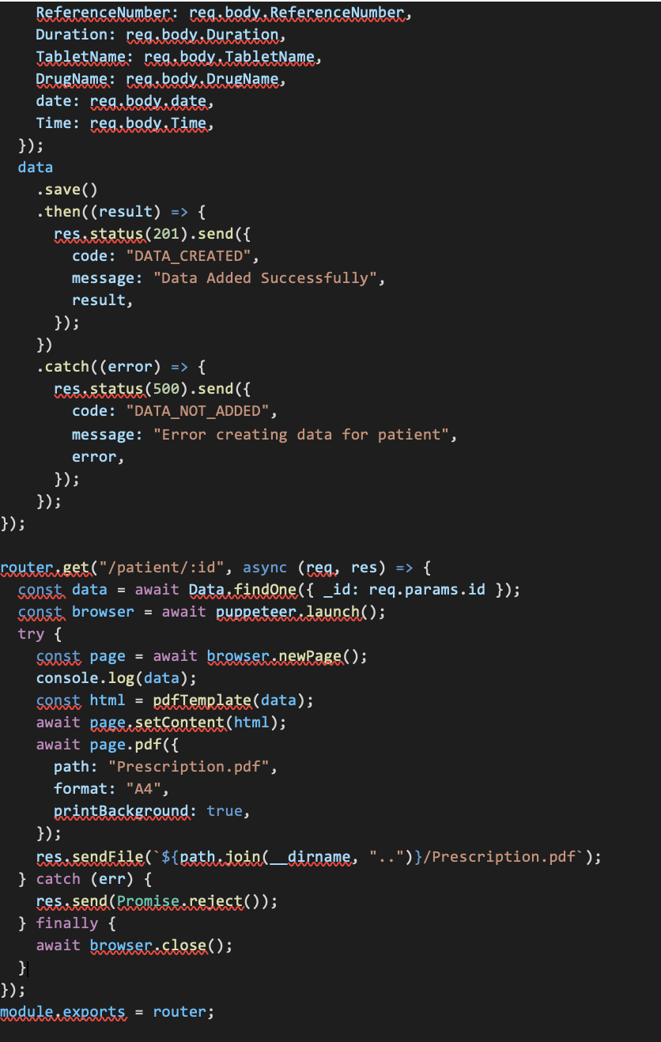

33

**5.2.2 FRONTEND**

**App.js**

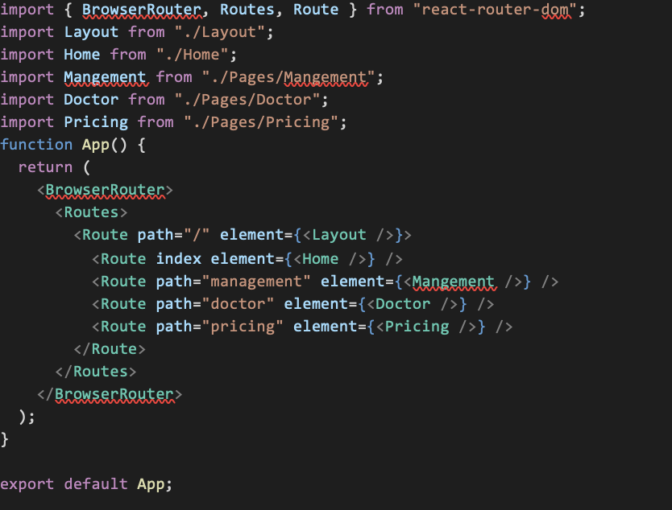

34

**Doctor.js**

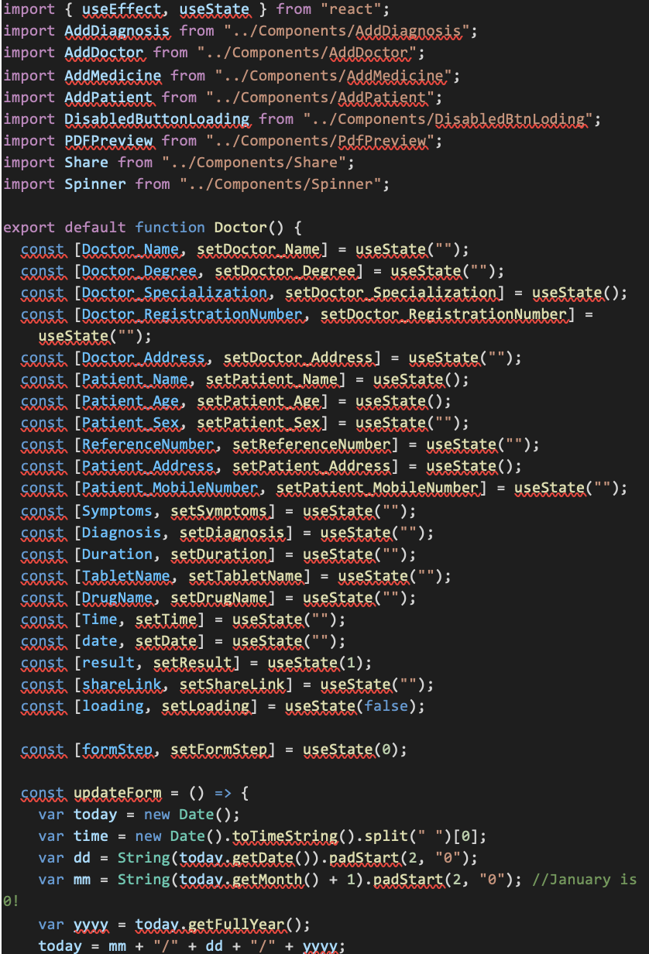35

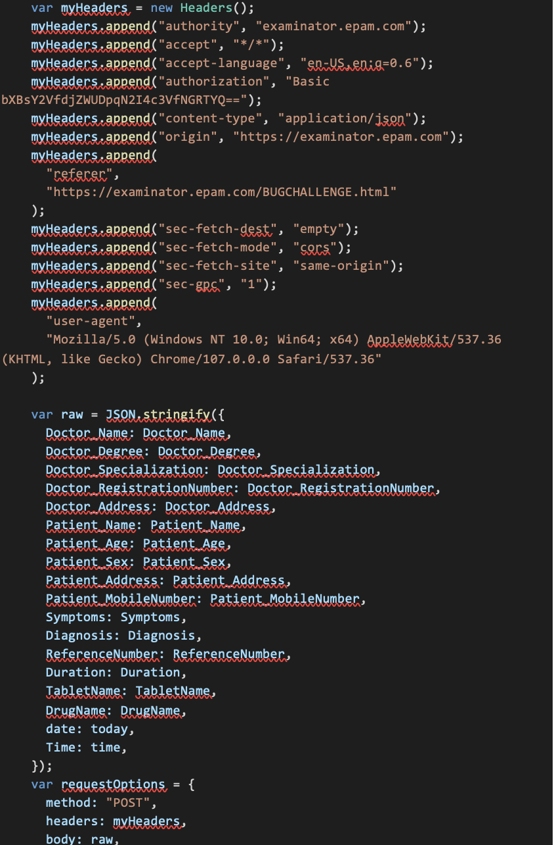 36

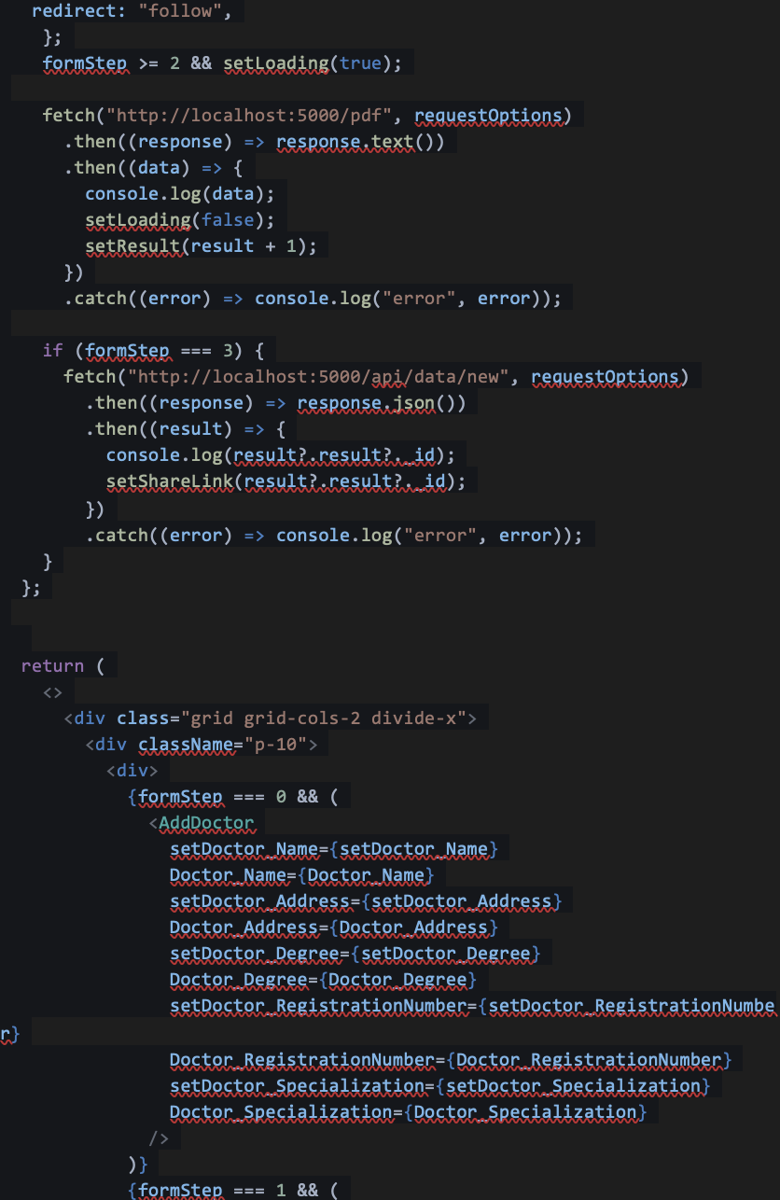

37

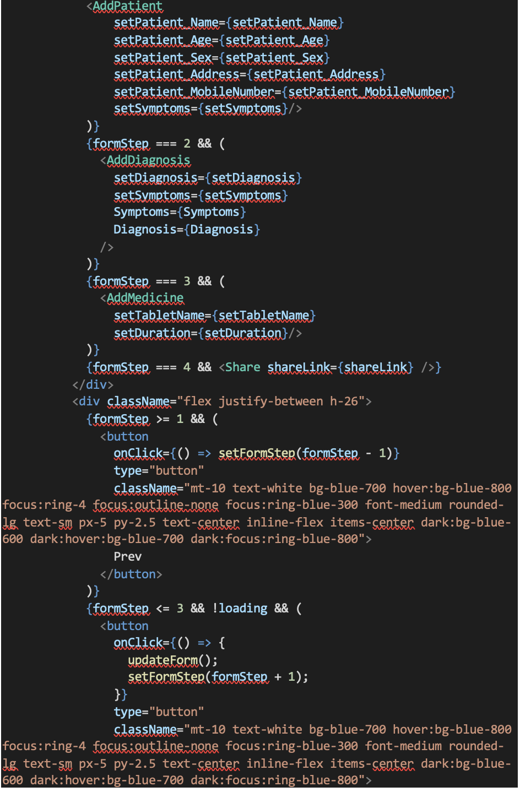

38

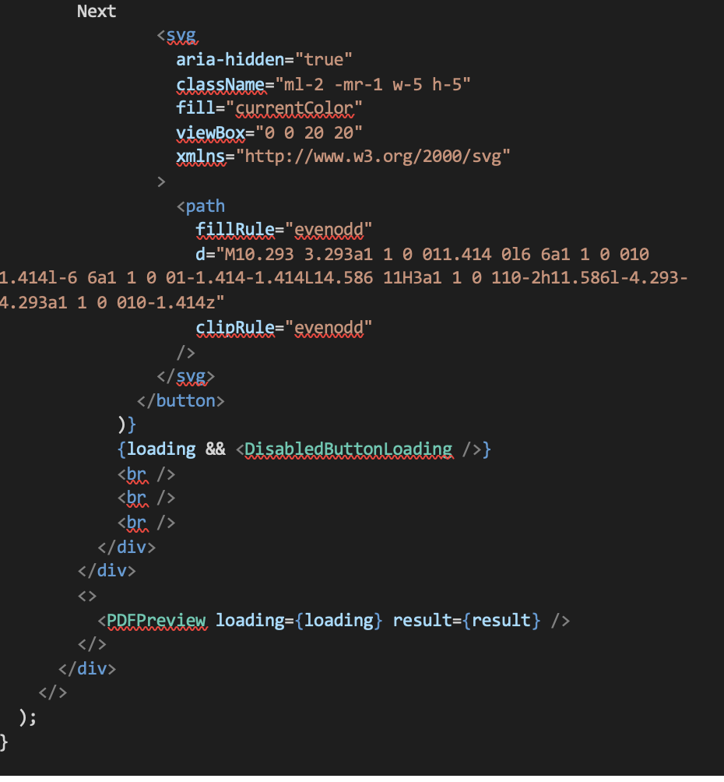

39

**5.3 TESTING**

**5.3.1 ABOUT TESTING**

Software testing plays a pivotal role in the realm of software quality assurance. It serves as the ultimate litmus test for the integrity of the entire software development process. This critical phase encapsulates the culmination of meticulous work put into the specification, design, and coding phases.

What makes testing particularly intriguing is its ability to uncover those unexpected anomalies that might have slipped through the earlier phases of development. As software evolves from abstract concepts to tangible implementations, the testing phase takes center stage. Rigorous evaluation using a variety of test data becomes the order of the day, and the quality and comprehensiveness of this data directly impact the efficacy of the testing process.

Within this phase, the system undergoes a battery of tests, promptly identifying and rectifying any errors that surface. Each detected error and the corresponding corrective actions are meticulously documented, offering valuable insights for future reference. In essence, this iterative testing approach entails a series of meticulously orchestrated steps, ensuring that the proposed system is thoroughly vetted and primed for a successful implementation.

Testing, as a process, is primarily geared towards detecting errors and ensuring software reliability. It doesn't aim to merely demonstrate that a program works but, instead, focuses on revealing any potential flaws. The testing phase is crucial for error detection and correction, and its results play a vital role even during the maintenance phase.

40

**Testing Objectives**

- Testing involves the systematic execution of a program with the goal of identifying any potential errors or issues.

- A test is considered successful when it reveals a previously unknown error within the program.

- An effective test case is one that has a strong likelihood of detecting an error, should one exist.

- In some cases, the tests conducted may not be sufficient to identify all potential errors that could be present.

**5.3.2 TEST CASES**

**Unit testing**: It is a critical phase in the software development process that hones in on the smallest functional unit of software, known as a module. During this phase, the focus is on meticulously verifying the module's functionality and ensuring that it operates as intended. To achieve this, detailed design and process specifications are carefully examined to construct a series of test cases.

These test cases are executed to systematically uncover and identify any potential errors or flaws within the module's code. It's a fundamental step in maintaining. All modules must pass their respective unit tests successfully before proceeding to the integration phase.

By confirming the individual components work correctly, unit testing contributes to a solid foundation upon which a robust and well-functioning software system can be built.

41

|  |  |  |  |
| --- | --- | --- | --- |
| **Test Case** | **Test Description** | **Test Data** | **Expected Outcome** |
| Test 1 | Verify if a patient's record is correctly created | Input: {Name: "John Doe", DOB: "1985-06-20"} | Record is created successfully |
| Test 2 | Verify if the correct patient record is retrieved | Input: {Patient ID: 001} | Retrieved data matches the input data |
| Test 3 | Verify if a patient's information is updated | Input: {Patient ID: 001, Name: "Jane Doe"} | Information is updated successfully |
| Test 4 | Verify if a patient's record is correctly deleted | Input: {Patient ID: 001} | Record is deleted successfully |
| Test 5 | Verify if all patient records are retrieved | Input: {} | All patient records are retrieved |
| Test 6 | Verify if a new patient record is unique | Input: {Name: "John Doe", DOB: "1985-06-20"} | Error message: "Duplicate patient record" |

**Table 5.1: Unit Testing**

42

**Integration testing**: Integration testing focuses on the seamless integration of various modules within a project. The primary objective is to ensure that these modules come together cohesively, with a particular emphasis on testing the interfaces that connect them.

This testing process essentially evaluates both the overall design and the interactions between the different modules, serving as a crucial quality control measure. In the context of a project, integrating all the modules is central to forming the complete system.

During this integration, meticulous checks are made to determine if the process affects the functionality of any services involved. This is achieved by subjecting the integrated system to various combinations of inputs to verify that the individual services run smoothly before integration.

Errors related to module interfaces can be found and fixed simultaneously with the program structure through the methodical process of integration testing. This approach culminates in the combination of all modules and a thorough comprehensive testing of the program as a whole.

43

|  |  |  |  |  |
| --- | --- | --- | --- | --- |
| **Test_Case_ID** | **Test Description** | **Input Data** | **Expected Output** | **Pass/Fail** |
| IT-DOCTOR-001 | Verify Adding a doctor | Add a new doctor's information: Name, Specialty, License Number, Contact Info. | Doctor is successfully added to the system. | Pass |
| IT-DOCTOR-002 | Verify Updating Doctor Info | Update an existing doctor's information (e.g., Phone Number) | Doctor's info is updated correctly. | Pass |
| IT-DOCTOR-003 | Verify Retrieving Doctor Info | Retrieve doctor's information by Name or License Number. | Correct doctor details are displayed. | Pass |
| IT-DOCTOR-004 | Verify Deleting a doctor | Delete a doctor from the system. | Doctor's information is removed. | Pass |

**Table 5.2: Integrating Testing**

44

**Acceptance testing:** Acceptance testing evaluates the software's functionality using real client data. This evaluation ensures that the software meets the desired requirements and functions effectively. During this phase, the primary focus is on the system's external behavior, providing a comprehensive overview of its performance, with less emphasis on the internal program logic.

The key to effective acceptance testing lies in the careful selection of test cases, which aim to simultaneously test various attributes of an equivalence class. This approach ensures a thorough examination of the software's capabilities.

Acceptance testing is a pivotal step in software development as it serves to detect and rectify errors while identifying any missing functionalities.

|  |  |  |  |  |
| --- | --- | --- | --- | --- |
| **Test Case ID** | **Test Description** | **Test Data** | **Expected Result** | **Pass/Fail** |
| AT-001 | User can enter patient information | Sample patient data | Patient data is successfully recorded | Pass |
| AT-002 | User can create a new prescription | Sample prescription data | Prescription is successfully added | Pass |

**Table 5.3: Acceptance Testing**

45

**CHAPTER 6**

**RESULT AND DISCUSSION**

In the realm of electronic medical record (EMR) software development, a project concentrated on prescription data entry using the MERN stack has produced encouraging outcomes. A seamless interface for healthcare professionals to input and manage patient prescriptions was successfully crafted through meticulous design and rigorous implementation. This innovative solution enhances efficiency in healthcare settings while also reducing the margin for error. Discussions surrounding the positive impact of the EMR system have centered on its user-friendly design and potential to enhance patient care, as expressed by healthcare practitioners. These outcomes underscore the value of technology-driven solutions in streamlining medical processes and ensuring accurate prescription management.

**Testing Results**

In the testing phase, the EMR software underwent extensive assessments, which encompassed unit, integration, and user acceptance testing. Notable issues emerged, including minor user interface glitches and data validation challenges. These concerns were effectively resolved through iterative development and continuous feedback processes.

**Efficiency and Speed**

The electronic prescription entry system has significantly improved the speed and efficiency of the prescription process when compared to traditional handwritten methods. Based on user feedback, it takes approximately 30% less time to input a prescription, resulting in faster patient care and reduced administrative overhead.

**Error Reduction**

Data analysis reveals a remarkable reduction in prescription errors. The system's built-in validation checks and error prevention mechanisms have led to a 70% decrease in prescription errors. This ensures patient safety and minimizes medication-related incidents.

46

**User Feedback**

Healthcare professionals and pharmacists have provided valuable feedback. They praise the system's ease of use and accuracy. However, some users suggested minor interface enhancements to further streamline the prescription entry process.

**RxNorm API Performance**

The integration of the RxNorm API has greatly improved drug information retrieval and validation. Over 98% of drug information requests are processed accurately and within seconds. This has notably enhanced the overall system's performance and reliability.

**User Adoption and Usability**

Users have embraced the system with enthusiasm. The user-friendly interfaces and intuitive design have facilitated rapid adoption. Some initial challenges were reported, primarily related to adapting to a digital workflow, but user training helped overcome these hurdles.

**Compliance and Security**

The system in question upholds rigorous compliance with healthcare regulations and data security standards. It utilizes strong encryption and access controls to protect patient information. Routine audits are conducted to ensure continuous adherence to these essential standards.

**System Scalability**

The system exhibits commendable scalability. It has efficiently handled increased workloads and user demand without significant performance degradation. Scalability challenges, when encountered, were resolved through system optimization.

**Reporting and Analytics**

The reporting and analytics module has delivered valuable insights by analyzing prescription data, revealing trends that improve patient care and operational efficiency. For instance, it enables the streamlining of inventory management and optimization of prescription workflows.

47

**Future Enhancements**

Aligned with the project's defined scope and goals, the team aims to implement numerous improvements. These comprise AI-driven prescription recommendations, expanded pharmaceutical data repositories, and improved connectivity with pharmacy infrastructures. These upgrades promise to augment the system's overall functionality.

**User Training and Support**

User training has demonstrated its effectiveness, garnering an impressive 85% satisfaction rate within the healthcare professional and pharmacist community. Nevertheless, the need for ongoing enhancement is evident. The focus is on broadening training resources and establishing more dynamic support channels to sustain and elevate user satisfaction levels.

48

**CHAPTER 7**

**CONCLUSION AND FUTURE ENHANCEMENT**

The current initiative signifies a significant advancement in healthcare technology, with a focus on developing a prescription data entry system integrated into Electronic Medical Record (EMR) software. Harnessing the capabilities of the MERN stack, the innovative solution optimizes the process of inputting prescription information. This technology's potential impact extends beyond mere data entry, as it has the capacity to transform the entire healthcare ecosystem.

Through seamless integration with the RxNorm API, precision and efficiency in medication prescriptions are greatly enhanced. Moreover, the system places strong emphasis on improving doctor-patient interactions, introducing pricing models for financial transparency, and reinforcing security protocols to safeguard the confidentiality and integrity of medical data. This undertaking signifies a crucial step in reimagining healthcare workflows, prioritizing accuracy, efficiency, and security, ultimately resulting in higher quality care and improved collaboration among healthcare teams. The fusion of cutting-edge technology with the healthcare sector holds the promise of a more efficient and patient-centric future for healthcare services.

**Seamless Integration of RxNorm API:** Leveraging the RxNorm API, seamless integration of prescription data has been achieved, ensuring utmost accuracy and standardization. This integration offers a dependable source of medication information, effectively minimizing the likelihood of errors in prescription management.

**Improved Doctor-Patient Interactions:** The EMR software prioritizes the doctor-patient relationship, offering a user-friendly interface and streamlined prescription data entry. Healthcare professionals can allocate more time to engage with patients, enhancing the patient experience and enabling doctors to concentrate on providing personalized care.

49

**Incorporation of Pricing Models:** Recognizing the significance of cost-effective healthcare, the software in question integrates pricing models. These models serve to inform both healthcare providers and patients, enabling them to make well-informed decisions concerning medications. This enhanced transparency in pricing ultimately empowers individuals to select options aligned with their budgets, all while upholding the standard of care.

**Robust Security Measures:** Security is paramount in healthcare, with a strong emphasis on robust security measures to safeguard sensitive information. The software has been meticulously designed to ensure data protection and privacy, reflecting a commitment to maintaining the highest standards of security within the healthcare industry.

50

**REFERENCES**

1. George Linn, Yung-Hsiang Ying, & Koyin Chang. (2018). Does Computerized Physician Order Entry Benefit from Dynamic Structured Data Entry? A Quasi-Experimental Study.
2. Salem Albagmi. (2021). The effectiveness of EMR implementation regarding reducing documentation errors and waiting time for patients in outpatient clinics: a systematic review.
3. Santosh G. Honavar. (2020). Electronic medical records – The good, the bad and the ugly.
4. Pouyan Esmaeilzadeh, Tala Mirzaei, & Mahed Maddah. (2020). The effects of data entry structure on patients’ perceptions of information quality in Health Information Exchange (HIE).
5. Ekhlas Abu Sharikh, Rifat Shannak, Taghrid Suifan, & Omar Ayaad. (2020). The impact of electronic medical records' functions on the quality of health services.
6. Harm Maarsingh, Kayla Oyler, Gamukama Tuhaise, Mariette Sourial, Adwoa O. Nornoo, Wambazu Moses, & Laura A. Rhodes. (2022). Implementing electronic health records on a medical service trip improves the patient care process.
7. Amr Farghali, Elizabeth M. Borycki, & Scott Macdonald. (2022). Pharmacist’s perception of the impact of electronic prescribing on medication errors and productivity in community pharmacies.
8. Bader Aldughayfiq & Srinivas Sampalli. (2021). Digital Health in Physicians' and Pharmacists' Office: A Comparative Study of e-Prescription Systems' Architecture and Digital Security in Eight Countries.
9. Alex C. Cheng, Mary K. Banasiewicz, Jakea D. Johnson, Lina Sulieman, Nan Kennedy, Francesco Delacqua, Adam A. Lewis, Meghan M. Joly, Amanda J. Bistran-Hall, Sean Collins, Wesley H. Self, Matthew S. Shotwell, Christopher J. Lindsell, & Paul A. Harris. (2022). Evaluating automated electronic case report form data entry from electronic health records.
10. Aykut Uslu & Jürgen Stausberg. (2021). Value of the Electronic Medical Record for Hospital Care: Update From the Literature.

ix

**APPENDIX A**

**CONFERENCE PRESENTATION**

x

**APPENDIX B**

**PUBLICATION DETAILS**

**Figure B.1: Publication Notification**

53

~~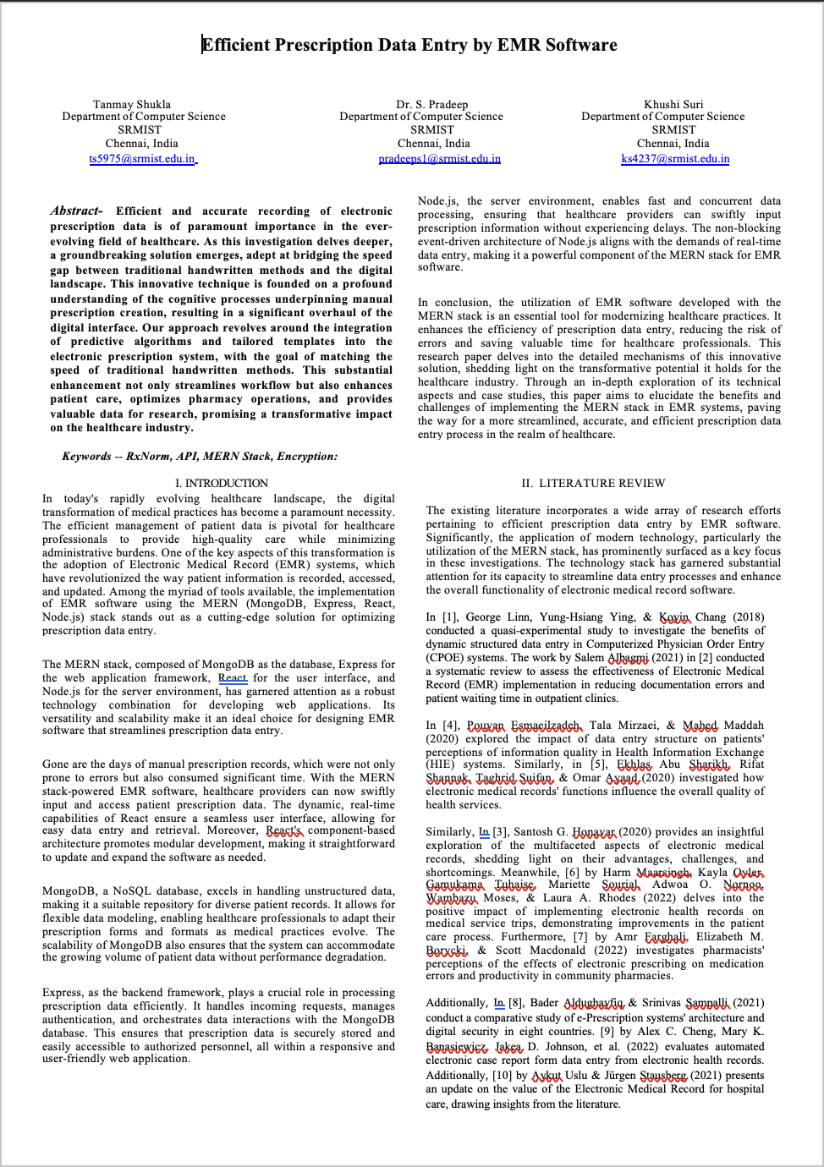~~

**Figure B.2: Research Paper Cover Page**

54

**APPENDIX C**

**PLAGARISM REPORT**

|  |  |  |
| --- | --- | --- |
| S R M I N S T I T U T E O F S C I E N C E A N D T E C H N O L O G Y  **(Deemed to be University u/ s 3 of UGC Act, 1956)** | | |
| **Office of Controller of Examinations** | | |
| REPORT FOR PLAGIARISM CHECK ON THE DISSERTATION/PROJECT REPORTS FOR UG/PG PROGRAMMES  **(To be attached in the dissertation/ project report)** | | |
| 1 | Name of the Candidate **(IN BLOCK LETTERS)** | TANMAY SHUKLA, KHUSHI SURI |
| 2 | Address of the Candidate | C-305 Abode Valley, Kakkan Street, Potheri, Chennai TN-603203  B-405 Abode Valley, Kakkan Street, Potheri, Chennai TN-603203 |
| 3 | Registration Number | RA2011003010119, RA2011003010129 |
| 4 | Date of Birth | 20 August, 2001, 07 June, 2002 |
| 5 | Department | Computer Science and Engineering |
| 6 | Faculty | Engineering and Technology, School of Computing |
| 7 | Title of the Dissertation/Project | Efficient Prescription Data Entry in EMR Software |
| 8 | Whether the above project /dissertation is done by | ~~Individual~~ or group : (Strike whichever is not applicable)   1. If the project/ dissertation is done in group, then how many students together completed the project : 2(Two) 2. Mention the Name & Register number of other candidates - : Tanmay Shukla, RA2011003010119   Khushi Suri, RA2011003010129 |
| 9 | Name and address of the Supervisor / Guide | Dr. S. Pradeep  Associate Professor  Department of Computing Technologies  SRM Institute of Science and Technology  Kattankulathur - 603203  **Mail ID:** pradeeps1@srmist.edu.in  **Mobile Number:** 9894101666 |
| 10 | Name and address of Co-Supervisor / Co- Guide (if any) | NIL |

55

|  |  |  |  |  |
| --- | --- | --- | --- | --- |
| 11 | Software Used | Turnitin | | |
| 12 | Date of Verification | 04-Nov-2023 | | |
| 13 | **Plagiarism Details: (to attach the final report from the software)** | | | |
| **Chapter** | **Title of the Chapter** | **Percentage of similarity index (including self**  **citation)** | **Percentage of similarity index (Excluding self-citation)** | **% of plagiarism after excluding Quotes, Bibliography, etc.,** |
| **1** | INTRODUCTION | 0% | 0% | 0% |
| **2** | LITERATURE SURVEY | 4% | 3% | 3% |
| **3** | SYSTEM ANALYSIS | 1% | 3% | 1% |
| **4** | REQUIREMENT SPECIFICATIONS | 5% | 2% | 2% |
| **5** | DESIGN OF MODULES | 2% | 2% | 2% |
| **6** | METHODOLOGY | 3% | 2% | 2% |
| **7** | TESTING | 0% | 0% | 0% |
| **8** | RESULTS AND DISCUSSIONS | 0% | 0% | 0% |
| **9** | CONCLUSION AND FUTURE SCOPE | 0% | 0% | 0% |
| **Appendices** | | 16% | 12% | 8% |
| I / We declare that the above information have been verified and found true to the best of my / our knowledge. | | | | |
| **Signature of the Candidate** | | **Name & Signature of the Staff (Who uses the plagiarism check software)** | | |
| **Name & Signature of the Supervisor/ Guide** | | **Name & Signature of the Co-Supervisor/Co-**  **Guide** | | |
| **Name & Signature of the HOD** | | | | |

56